HSO-2209-00278: Validation on e-addresses and phone numbers of customers (Welkoop)

Problem description
For the customers, Welkoop wants to have a validation on the email addresses and phone numbers.

Email validation
The email address should have at least @, but they also want it to be unique to the organization (customer group) . The unique validation is only for the general email address (marked as primary), the invoice or other email addresses in contacts should only be validated on @. So two customers cannot have the same primary e-address, but can it happen one customer to have test@hso.com as primary address and second customer to have it as non primary.

Expected behavior
Customer 10001300 has email address that is set to be primary as test-test@hso.com.
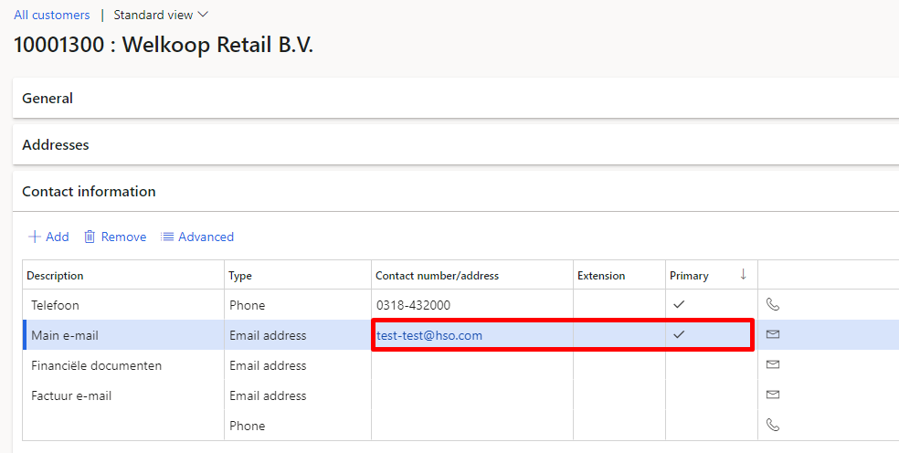

If we try to set the same e-mail address on customer 100128, we should receive following message:
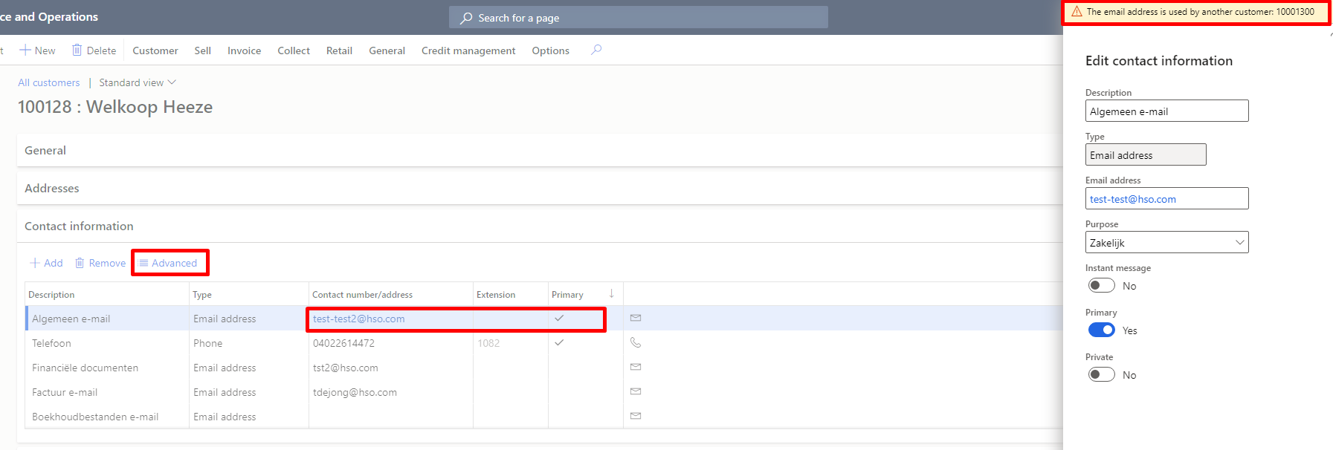

If we try to set an e-mail address without @ sign (regardless if it’s primary or not) we should get following warning message:

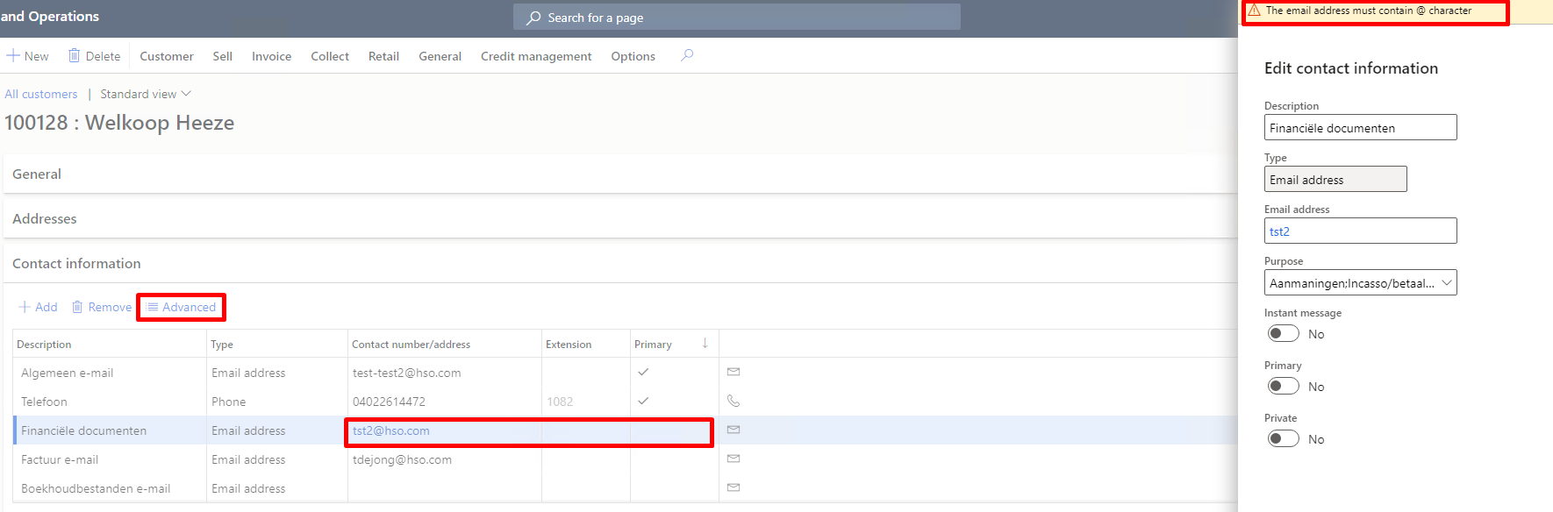

Phone validation
For the phone only numbers and as exception the + sign. No validation on landcode. Maximum is 15 numbers. All below combinations are allowed.

0261234567, +31261234567, 0031261234567

0612345678, +31612345678, 0031612345678

outside the Netherlands 00393421234567

Expected behavior
If we go to a customer and try to set the phone number which contains additional sign or has more than 15 digits, we should ge the following message:

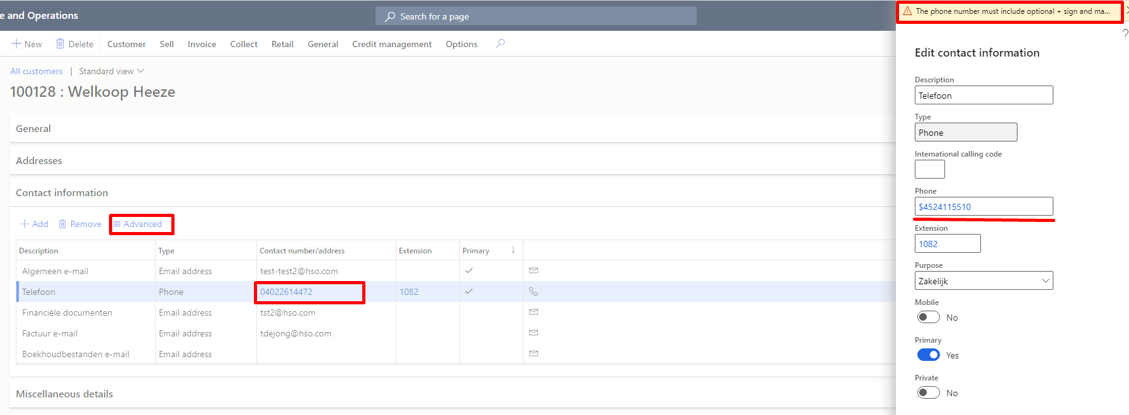

Warning message:
The phone number must include optional + sign and maximum 15 digits

Customers are now set up manually in D365FO (so no interface), but they prefer to have the validation on the tables so that for the future data management can be used for importing.

